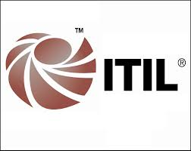

ITIL and COBIT 5 COMPARISON

On one side you can say they are two different ways (frameworks) of doing the same thing (IT Management/Governance) but core difference is in understanding Information Technology evolution from an Enterprise Unit that helps (through IT services) different functional areas (operations, S&M, Customer Service, Procurement, etc.) in order to achieve their goals/stakeholder needs to a full-fledged and mature functional area that aligns itself directly to Enterprise Level Stakeholders and their Enterprise Level Goals. In this context IT is in a phase of coming out of functional area shadows (Finance, HR, Procurement, ,etc.) supported by ITIL Framework and getting into the realm of Enterprise Level challenges/goals supported by COBIT 4.1 and now COBIT 5.

ITIL COBIT

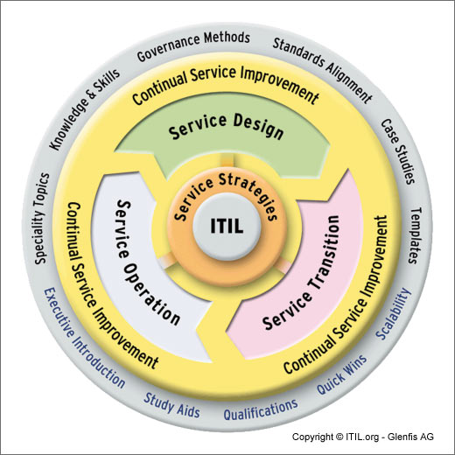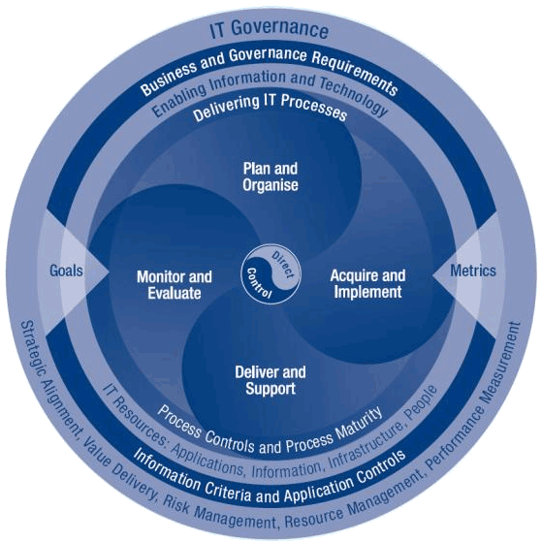

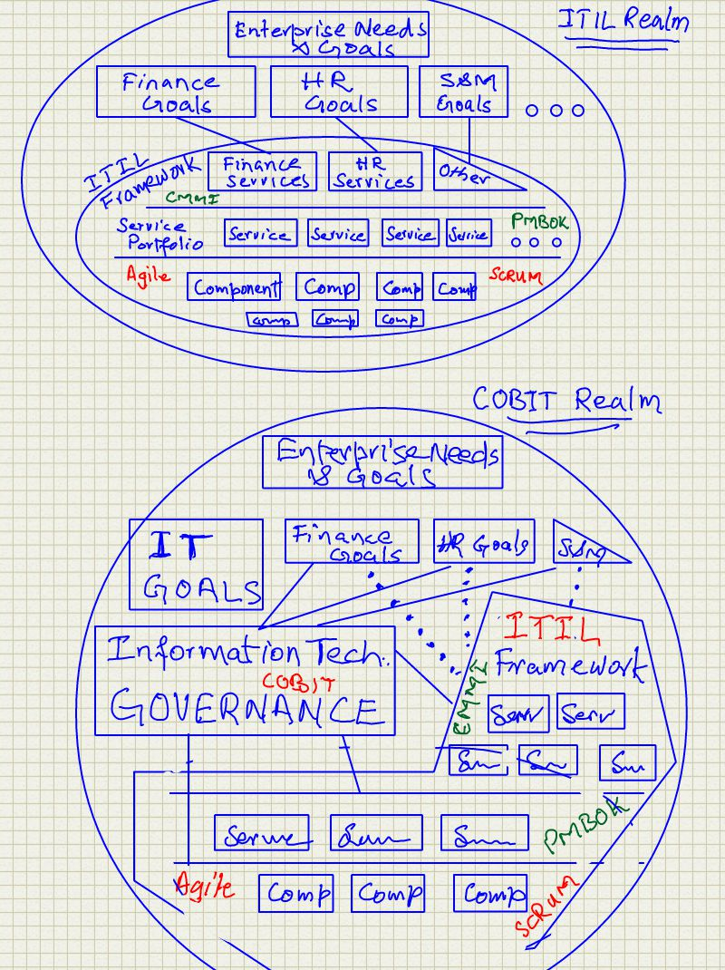

Judgment Before we go to Detailed Comparison:

First question is can ITIL adopt and adapt to become one comprehensive framework? A framework that includes all that COBIT claims to be missing in ITIL. My answer is plain “No” but I would understand if somebody does not agree. I believe ITIL is bottom up evolutionary IT Framework for IT Services while COBIT is top down end-to-end single framework for all IT with a holistic approach. ITIL can include some more planning and governance level functions but its fundamental approach will not change from that focused on IT Services and it will remain strong only in that area. COBIT is able to adopt ITIL for some processes in Build/Acqire/Implement (BAI01, BAI02, BAI03 to name a few) and will continue to do so. COBIT is not meant to replace ITIL and it will not attempt to do so. Similar argument applies to TOGAF, CMMI, PMBOK, DMBOK, BPM, Agile, FDD, eXtremePrgramming, and SCRUM.

Second question, “is COBIT really needed”? That is also an interesting question. My straight answer is “Yes, absolutely” and there are many reasons for this judgment:
- IT is still young (50 to 60 years old) and has gone through rapid changes. It necessitated structured and methodical approach (Frameworks) along the way resulting in frameworks for Services, database/information, Program/Project Management, Service reliability assessment, faster development, and managing frequent business changes. Presently, IT is focused on “managing” explosive demand in service needs, service maturity requirements, and service integration. However, pretty soon IT will feel additional need to change focus from functional area (Finance, HR, Sales, Products, Procurement) specific services to more of Enterprise Level Stakeholder needs, Enterprise Goals, Enterprise Architecture, and Enterprise Strategy. The segmented approach with many frameworks will not be able to respond and hence a need for one comprehensive framework that leverages all best practices in existing ones. For now, COBIT is the only answer as far as I know.
- IT needs a separate Org Structures to focus only on alignment of IT with Enterprise Goals and monitor them as closely as possible. This structure should not be worried about the day to day work of actually achieving goals. Hence the solution called separation of Governance from Management.
- A need for single service repository is without any doubt. However, there is a bigger need for bringing all this together (one framework), benefit realization, Risk Assessment and Management and continuous and close monitoring in a holistic way.

Evolution View:

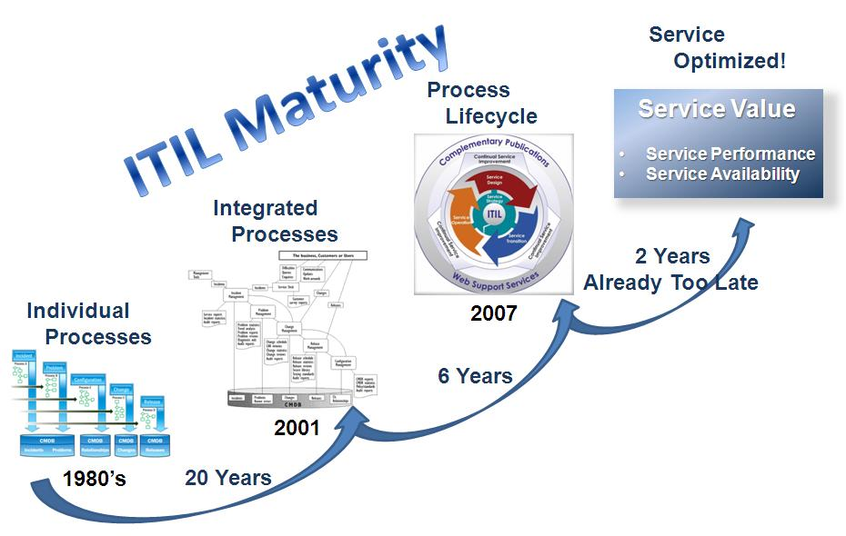

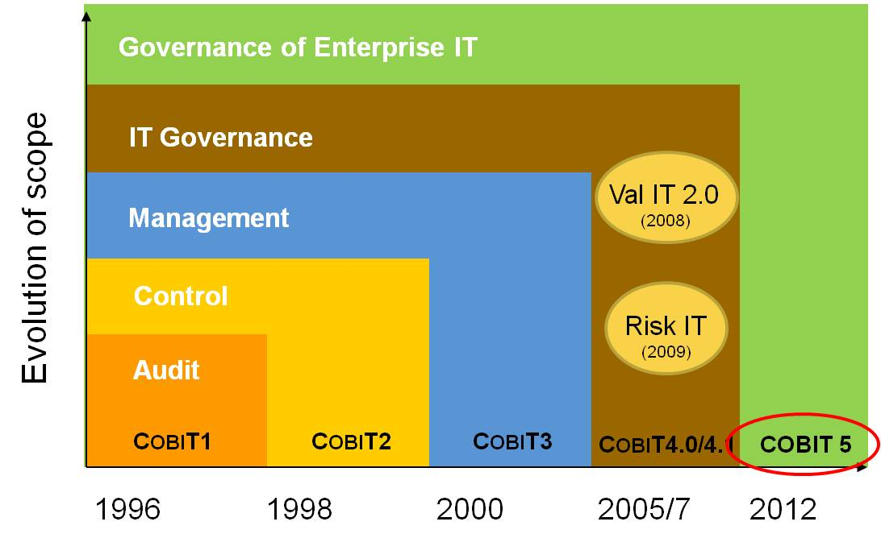
Level of Interest as of March, 2014

There is no comparison. ITIL is overwhelmingly getting more hits as per analysis from google searches.

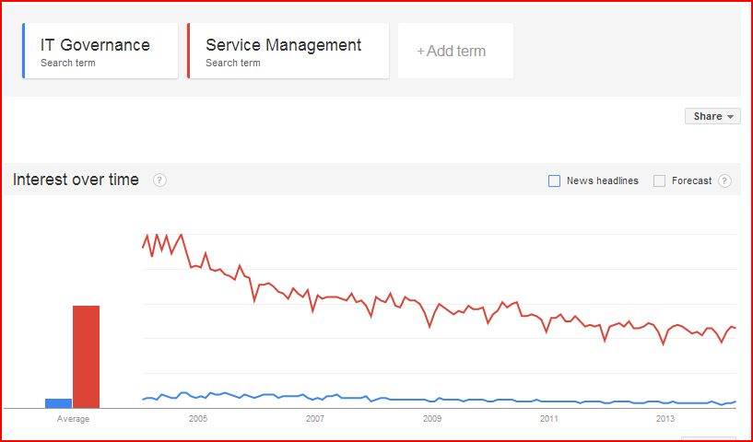

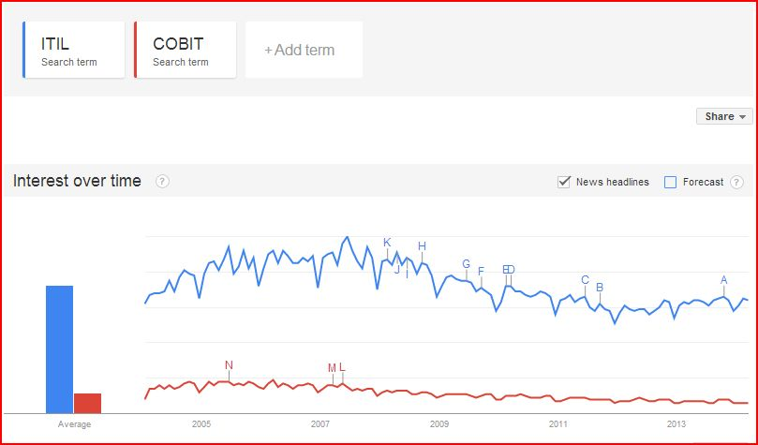

Detail Process Mapping: This is based on COBIT5 Business Processes as of March 30, 2014

COBIT5 | ITIL V3 2011
Governance (EDM01, EDM02, EDM03, EDM04, EDM05) | None
Management | Covers some
APO01 | Continual Service Improvement 4.1 (the 7 steps process)
APO02 | Service Strategy 4.1
APO03 – Enterprise Architecture | None
APO04 – Manage Innovation | None
APO05 | Service Strategy 4.1  Service Portfolio Management
APO06 | Service Strategy 4.3  Financial Management of IT Services
APO07 – Manage Human Resource | None
APO08 | 4.4 Demand Management  4.5 Business Relations Management
APO09 | Service Strategy, 4.4 Demand Mgmt  Service Strategy, 4.2 Service Portfolio Mgmt  Service Design, 4.2 Service Catalogue Mgmt  Service Design, 4.3 Service Level Mgmt
APO10 | 4.8 Supplier Mgmt
APO11 – Manage Quality | None
APO12 – Manage Risk | None
APO13 | Service Design, 4.7 Service Security Mgmt
BAI01 – Manage Programs and Projects | None
BAI02 | Service Design, 4.1 Design Coordination
BAI03 – Manage Solution Identification and Build | None
BAI04 | 4.4 Availability Mgmt  4.5 Capacity Mgmt
BAI05 – Manage Organizational Change Enablement | None
BAI06 | Service Transition, 4.2 Change Mgmt
BAI07 | Service Transition, 4.1, 4.4, 4.5, and 4.6
BAI08 | Service Transition, 4.7 Knowledge Mgmt
BAI09 | Service Transition, 4.3 Service Asset and Configuration Mgmt
BAI10 | Service Transition, 4.3 Service Asset and Configuration Mgmt
DSS01 | Service Operation – 4.1 Event Mgmt
DSS02 | Service Operation – 4.2 Incident Mgmt  Service Operation – 4.3 Request Fulfillment
DSS03 | Service Operation – 4.4 Problem Mgmt
DSS04 | Service Design – 4.7 Service Continuity Mgmt
DSS05 | Service Operation – 4.5 Access Mgmt
DSS06 – Manage Business Process Control | None

